Air France Internet Marketing

Hand-In Instructions: Send your MS Excel file via eLearning assignment link. Your filenames must include names in the form of “First Name Last Name” (if you work on your own) or “First Name Last Name 1 and First Name Last Name2” (if you work in a team).

Preparation: Read Air France Internet Marketing: Optimizing Google, Yahoo!, MSN, and Kayak Sponsored Search (which can be purchase following the link provided in the course outline), including the Spreadsheet Supplement (which can be downloaded via the eLearning assignment link). For any terms that you do not understand in the case or in this assignment sheet, please read the related slides and/or search online and get them clear.

Objective: Analyze summarized campaign metrics to determine optimal strategy to pursue for each publisher.

Your Task: Analyze summarized campaign metrics to determine optimal strategy to pursue for each publisher.

1. Add the following four metrics as four additional columns to the “DoubleClick” datasheet and calculate the value. Insert comments for each column header describing the metric (you may copy and paste the description provided below for each of them).
a. Net Revenue (Amount - Cost) measures overall publisher contribution to marketing campaign.
b. Return on Ad $ Spent (ROA) (Net Revenue / Cost) measures efficiency of generating net revenue from ad $ spent. If the cost is zero, you must show “0” as the value for the cell.
c. Average Revenue per Booking (Amount / # of Bookings) measures differences in revenue capture and may be indicative of differing customer segments captured by publishers. If # of Bookings is zero, you must show “NA” as the value for the cell.
d. Probability of Booking (CTR * TCR) measures the probability of generating a sale from a delivered impression. Note that “Trans. Conv.%” can be converted to TCR while “Engine Click Thru %” can be converted to CTR.

2. Create a PivotTable on a new sheet named “Pivot Table” (see Exhibit 7 for guidance). You PivotTable should show different campaigns by each publisher, keywords included in the respective campaign, Average of Return on Ad Dollar Spent, and Average of Avg. Cost per Click.

3. On a new datasheet (named “Summary”), create a “Publisher Comparison – Summary”. The summary should have information for the following metrics. Based on the summary table, comment on how different publishers perform on key performance indicators. You should include your comments on the same datasheet, below the summary table. Use a “text box” to include your comments.

Publisher Name | Sum of Net Revenue | Average Cost Per Click | Total Volume of Bookings | Average Revenue Per Booking | ROA | Probability of Booking | Sum of Click Charges | Cost/Booking
Google - Global
Google - US
MSN - Global
MSN - US
Overture - Global
Overture - US
Yahoo - US

4. On a new datasheet (named “Bubble Chart”), graph publishers on a bubble chart using the following dimensions: X=Probability of Booking, Y=Cost Per Click, Bubble Size=Total Costs or Total Funding.
a. Create four quadrants by drawing a line at the publisher average for CPC and another line at the publisher average for probability of booking.
b. Observe the quadrant in which a publisher falls and assign a strategy using the table below. Note that bubble size indicates current funding levels. In a text box, please comment on which publishers fall in which quadrant. Include key observations about each quadrant.
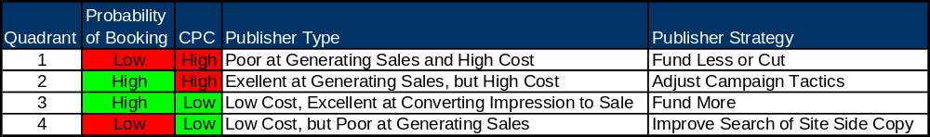

Grading Criteria (25 points)

Task 1: 4
Task 2: 4
Task 3: 10
Task 4: 7

